Day 1:
Dotnet Basics
Runed the first console application

Day 1 Notes
1.Why Dotnet?
Before dotnet, COM(component object model) is used to develop windows applications.
Disadvantages of COM are incomplete Object oriented programming and run only on Windows.
2.What is . NET.?
NET- Network enabled technology.
. - refers to object oriented programming language.
3.What the .NET framework provide?
framework: collection of small software integrated to develop applications
i).BCL(base class libraries)
collection of reusable classes and APIs that provide fundamental functionality like working with strings, collections, file I/O, networking, and more. It’s part of the larger .NET Framework Class Library (FCL), and it helps developers avoid writing low-level code for common tasks.
ii).CLR(common language Runtime)
It handles memory management, garbage collection, exception handling, security, and thread management. When we compile C# code, it gets converted to Intermediate Language (IL), and the CLR uses the Just-In-Time (JIT) compiler to convert IL into native machine code at runtime.
In short, the CLR runs the code, and the BCL provides the tools to write the code efficiently.
4. Three versions of the dotnet framework?
.NET Framework: runs only windows
.NET or .NETCore: platform independent
Xamarin/Mono": runs on all mobile OS including iOS and Android
5.Advantages of C#?
platform independent.
Open source.

Steps:
step 1: dotnet new console -n Application_name
step 2: cd Application_name
Step 3: dotnet build
Step 4: dotnet run
Basic Structure of C#:
Namespace usage: Used to group the all classes and interfaces that related to the project.
- Using System (imports the BCL and user defined name spaces)
Syntax: using NameSpaceName
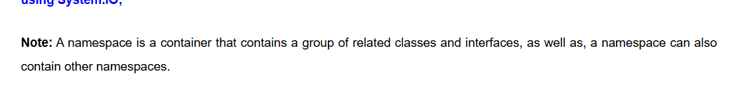
- User defined namespace
Syntax: namespace NameSpaceName

3. Class declaration
4. Program entry point ( main function)

